**Activity Diagram:  
  
Level:** 1.1  
**Name:** Registration & Login  
**Reference:** Use Case Diagram Level 1.1

|  |  |
| --- | --- |
| **https://lh7-rt.googleusercontent.com/docsz/AD_4nXfNiunzFs6bK0l3un61CkUJWskiJ9758T1PT7VeUZhjT0WtvO-sQ3LM5eP6sgJZxy57KAghcWrAmMXZnNuLwtfK-Rqh9rYdAEXs8eQME92dWyScPK6avoL0ChjDmuUqBiF7OLfXgxpMTBiX5ryWoSU?key=23u0T1OAyz5pxHQBC0E8LA** | **https://lh7-rt.googleusercontent.com/docsz/AD_4nXcrEai2OWlSE683Fxct0xi0h8VLEAZY5xPCyliwBVIR5nKyo481oQF-ADRDkyrNEWFwZHppKMg_uu2ld5O8G7dbyN0jkLEiEdpNXaPotK3QlkKdQzdMk8Ab6EUI-Nn0Bv7GI4UAP9Nsin-BZWPyUvw?key=23u0T1OAyz5pxHQBC0E8LA** |

|  |  |
| --- | --- |
| **https://lh7-rt.googleusercontent.com/docsz/AD_4nXe0eDk__FDdznGKuJCNjRI72Na76qVtjmE-i1im-aLPhaBhgp7cU6SE0v6zD1R5vxMEsm4I31iPGcEwV46-_g4RmRwPTlUwa0O45xrldPeLEcoqtyfpN1BWn-c96-J6juVj6NDC9mPwOnIffAmsgA?key=23u0T1OAyz5pxHQBC0E8LA** | **https://lh7-rt.googleusercontent.com/docsz/AD_4nXe-FcoAlMOg3w3cIMJ0yDUu-d9tE5ZMvVycmmnlTP6zbhvKmq-zyLZjsWf5-O-8vfvcHxCBFn6ivlUhtb85fDXL7Clu-wIyqBIImLcyJVT174e07VVfWbvpA_PXKhbwEXtE9nr7SvmtqfOCTtddsj4?key=23u0T1OAyz5pxHQBC0E8LA** |

**Level:** 1.2  
**Name:** Dashboard  
**Reference:** Use Case Diagram Level 1.2

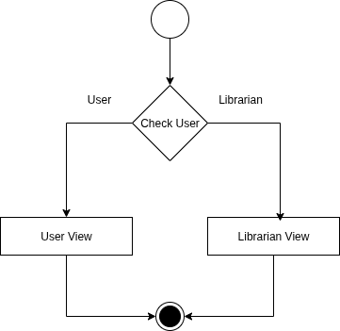

**Level:** 1.2.1  
**Name:** User View  
**Reference:** Use Case Diagram Level 1.2.1

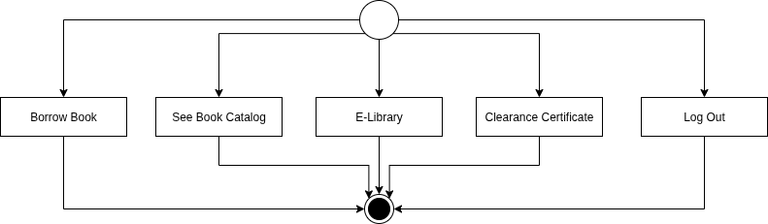

**Level:** 1.2.2  
**Name:** Librarian View  
**Reference:** Use Case Diagram Level 1.2.1

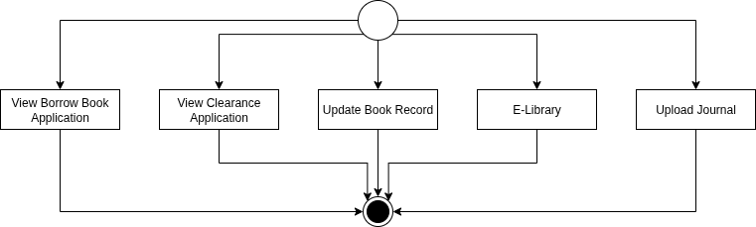

**Level:** 1.3  
**Name:** E-library  
**Reference:** Use Case Diagram Level 1.3  
  
 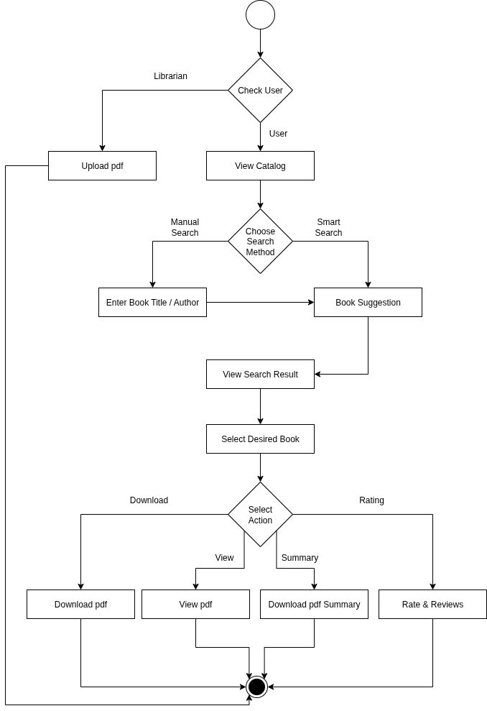

**Level:** 1.4  
**Name:** Borrow Book  
**Reference:** Use Case Diagram Level 1.4

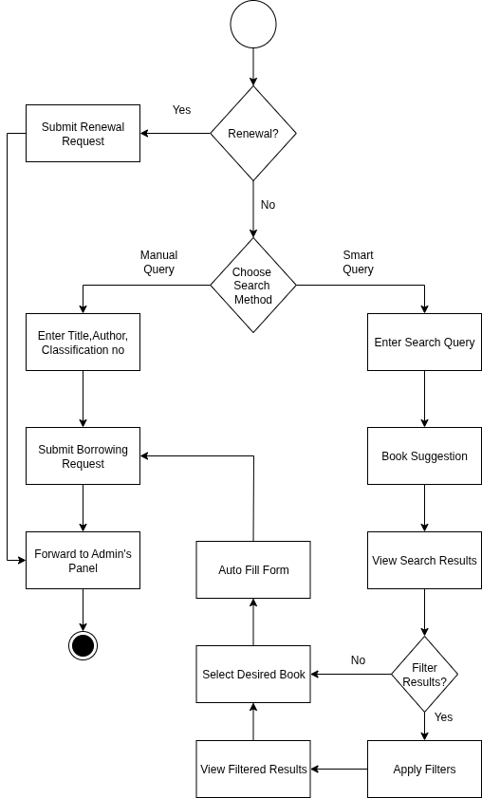

**Level:** 1.5  
**Name:** Approval  
**Reference:** Use Case Diagram Level 1.5

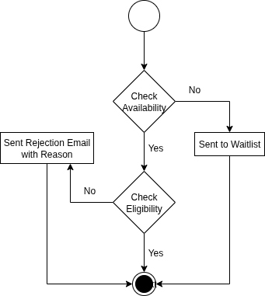

**Level:** 1.5.1  
**Name:** Availability  
**Reference:** Use Case Diagram Level 1.5.1  
  
 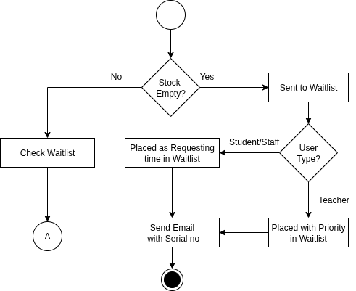

**Level:** 1.5.2  
**Name:** Eligibility  
**Reference:** Use Case Diagram Level 1.5.2

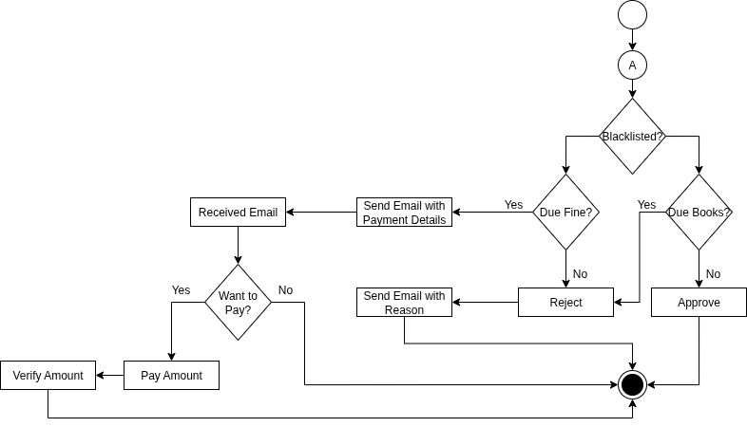

**Level:** 1.6  
**Name:** Clearance  
**Reference:** Use Case Diagram Level 1.6

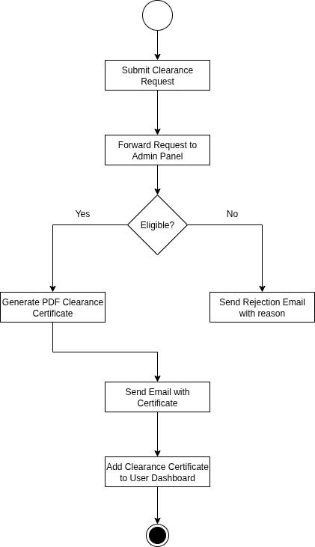

**Level:** 1.7  
**Name:** Eligibility  
**Reference:** Use Case Diagram Level 1.7

